

AHMEDABAD UNIVERSITY



Embedded System Design

**Project Title:**

Wirobot

**Prepared By:**

Ashutosh Kakadiya 1401075

Deep Talati 1401085

Harsh Mehta 1401086

KishanRaval 1401117

**Assisted By:**

Prof. Anurag Lakhalani

**Mentors:**

MS. Bhavika patel

MS. Kavita Anjariya

**Index:**

**Introduction……………………………………………………………………03**

**Block Diagram…………………………………………………………………04**

**Selection Criteria for Micro controller………………………………………05**

**Coasting table…………………………………………………………………06**

**Problems were Faced………………………………………………………….06**

**Circuit Diagram……………………………………………………………… 07**

**Snapshots………………………………………………………………………08**

**Flowcharts ……………………………………………………………………09**

**Code……………………………………………………………………………10**

**Conclusion ……………………………………………………………………14**

**Time Line……………………………………………………………………...15**

**References……………………………………………………………………..16**

**Introduction:**

In this exposed world with the increase in threat and security risks, the need of surveillance and control has also been increased. Which encouraged us to design a robot car which can be used wirelessly in any area having internet connection and can be controlled remotely. This kind of application can be adopted for surveillance at the border area. The same can be used for remotely observing house or office through the robot.

WiRobot (Wireless Robot) is a robot which can be used remotely. The WiRobot gets instructions from the user through internet over Wi-Fi network and acts as per the instruction given by the user. Along with this, WiRobot is also gathering the information about the surroundings and will send them to the user through internet.

**Block Diagram:**

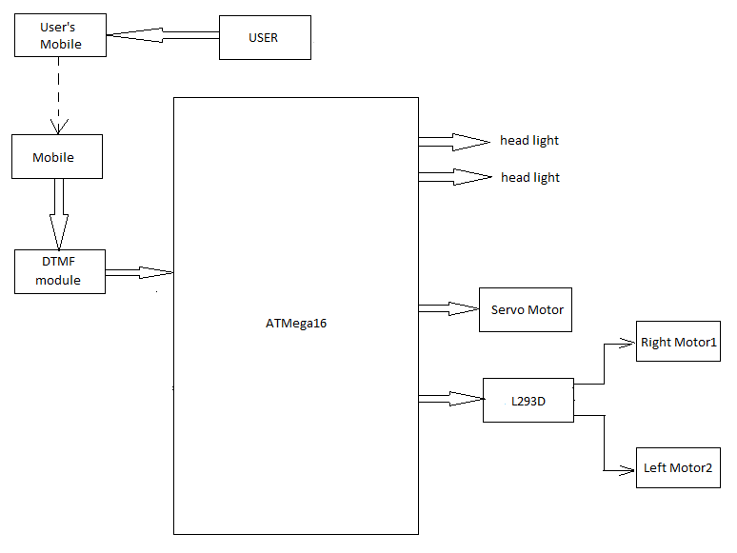

*Figure .I Block Diagram*

**Selection Criteria for major components:**

1. **Micro controller:**

|  |  |  |  |
| --- | --- | --- | --- |
| **Name of uc** | **ATmega 328p** | **ATmega 16** | **ATmega 32** |
| **CodeROM** | 8K | 16K | 32K |
| **DataRAM** | 1K | 1K | 2K |
| **DataEEPROM** | 0.5K | 0.5K | 1K |
| **IO pins** | 32 | 32 | 32 |
| **ADC** | 08 | 08 | 08 |
| **Timer** | 03 | 03 | 03 |

**Costing table:**

|  |  |  |  |
| --- | --- | --- | --- |
| **Component** | **Quantity** | **Cost per unit** | **Total Cost** |
| **Development Board** | 1 | 500 | 500 |
| **DTMF Module** | 1 | 400 | 400 |
| **Programmer** | 1 | 530 | 530 |
| **Servo Motor** | 1 | 450 | 450 |
| **9V battery** | 2 | 15 | 30 |
| **DC Motor** | 2 | 125 | 250 |
| **Car Tyre** | 4 | 20 | 80 |
| **Connectors** | 40 | 3 | 120 |
| **Chases** | 1 | 100 | 100 |
| **LED** | 2 | 5 | 10 |
| **Motor Driver** | 1 | 120 | 120 |
|  |  | Total | 2590 |

**Problems were Faced :**

* Data transfer  using Wi-Fi module was not working properly.
* DC & Servo motor interfacing .
* In programming of changing angle of servo motor
* Infra – Red sensor configuration with ATMEGA 32
* Data transfer through  DTMF module

**Circuit Diagram:**

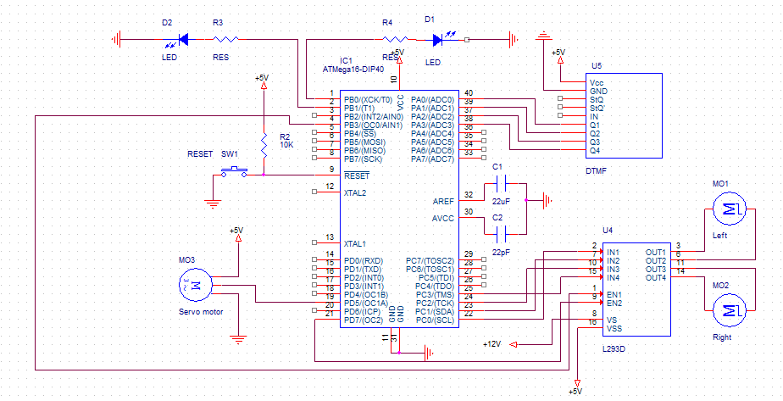

*Figure .II Circuit Diagram*

**Snap Shots of working model:**

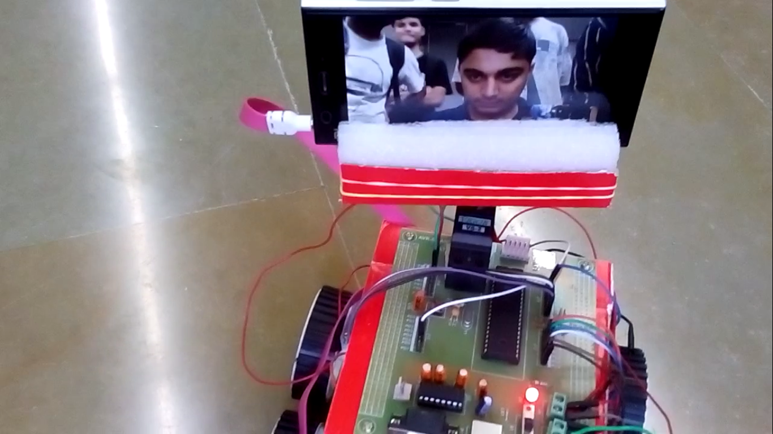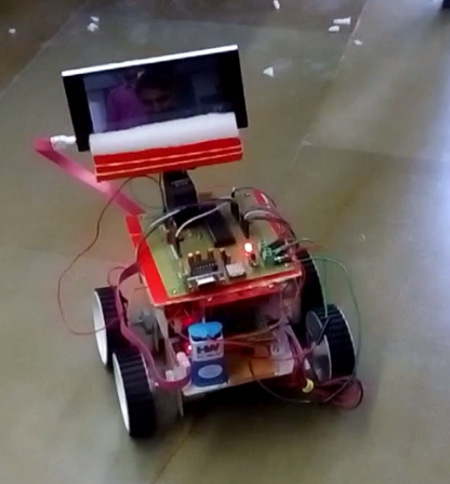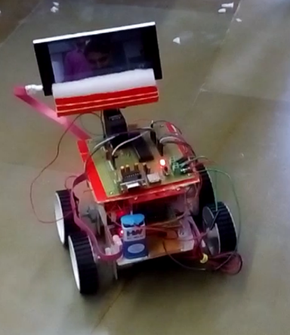

**Flow Chart:**



**Code:**

/*

 * Wirobot.c

 *

 * Created: 25-04-2016 19:01:53

 * Author : WIROBOT

 */

#define F_CPU 16000000

#include <avr/io.h>

#include <util/delay.h>

#include<avr/interrupt.h>

#define servo_min 0.600       //period in ms

#define servo_max 2.400       //period in ms

float D; //declaring global variable for change the degree of servo motor

void servo(float degree) {

int cmpMatch; // for calculating the compare match value for OCR1A

cmpMatch=  (int)(round( ( (float) (degree * (float) (servo_max - servo_min) / (float) 180.0) + servo_min) * 125) );

OCR1A= cmpMatch;

}

void changeDegree(unsigned char f)

{

if(f == 0){ // if flag is zero, motor will rotate 20 degree to the left

D = D + 20;

if(D > 180) // max degree is 180

{

D = 180;

}

}

else // if flag is not zero, motor will rotate 20 degree to the right

{

D = D - 20;

if(D <= 0)

{

D = 0; // minmum degree is 0

}

}

}

ISR (ADC_vect)// org 0x020

{

unsigned char low,high;

int num;

low = ADCL; //Diplay ADCL value @ PORTC

high = ADCH; //Diplay ADCH value @ PORTB

num = high;

num = num << 8;

num = num | low;

num = num & 0X03FF;

num = num * 4882.8;                        //(5/1024*1000) = 4.8828

//for converting from scale 0-1024 to 0-5 with precition of 2, we multiply the number by 4.8828

if(num < 3300)

{

PORTB = 0XFF;

}

else

{

PORTB = 0X00;

}

ADCSRA |= (1<<ADSC); // After completion of earlier conversion, start                 //new conversion

}

int main(void) {

DDRA = 0x00; // PORT A as input

DDRC = 0xFF; // PORT C as output

DDRB = 0xFF; // PORT B as output

D = 90; // intial position for servo motor is 90 degree

TCCR1A|=(1<<COM1A1)|(1<<COM1B1)|(1<<WGM11);        //NON Inverted PWM

TCCR1B|=(1<<WGM13)|(1<<WGM12)|(1<<CS11)|(1<<CS10); //PRESCALER=64 MODE 14(FAST PWM)

ICR1=4999;  //fPWM=50Hz

DDRD|=(1<<PD4)|(1<<PD5);       //PWM Pins as Output

ADMUX=0xC0;      //Reference Voltage VCC, Left Adjust, ADC0

ADCSRA=0b10001111;     //ADC enable,ADC interrupt enable, PRESCALER 128

sei();

ADCSRA |= (1<<ADSC);  //Start ADC conversion

servo(D); // calling servo function to set servo motor at 90 degree

//PORTC.4 and PORTC.5 is 1 for enable the motor driver

// table for motor direction

// PORTC.0  PORTC.1  PORTC.2  PORTC.3

// 0        0        0        0          stop

// 1        0        1        0          forward direction

// 0        1        0        1          backward direction

// 0        0        1        0          right turn

// 1        0        0        0          left turn

// table for user

// PORTA.0  PORTA.1  PORTA.2  PORTA.3

// 0        0        1        0          for forward direction

// 1        0        0        0          for backward direction

// 0        1        1        0          for right turn

// 0        1        0        0          for left turn

// 0        0        0        0          to stop

// 0        0        0        1          to rotate motor in left direction

// 0        0        1        1          to rotate motor in right direction

while(1)

{

PORTA =  PINA & 0xF0; // considering 4 MSB as input

if(PORTA == 0x20) // if 2 is send by the user, car will run in forward direction

{

PORTC = 0x3A;

}

else if(PORTA == 0x80) // if 8 is sent by the user, car will run in backward direction

{

PORTC = 0x35;

}

else if(PORTA == 0x60) // if 6 is sent by the user, car will take right turn

{

PORTC = 0x32;

}

else if(PORTA == 0x40) // if 4 is sent by the user, car will take left turn

{

PORTC = 0x38;

}

else if(PORTA == 0xA0) // if 0 is sent by the user, car will stop

{

PORTC = 0x00;

}

else if(PORTA == 0x10) // if 1 is sent by the user, servo motor will rotate in left direction

{

changeDegree(0);

_delay_ms(1000);

servo(D);

}

else if(PORTA == 0x30) // if 3 is sent by the user, servo motor will rotate in right direction.

{

changeDegree(1);

_delay_ms(1000);

servo(D);

}

}

}

**Conclusion:**

Motivation behind the project was to have a machine or robot which can do surveillance from a remote place and sends the data to the user. To control the robot, first we used WiFi Module (ESP8266), but because of some problems, we shifted to DTMF module which serves the same purpose. Also, headlights of the robot goes on whenever it detects low brightness around using LDR sensor.

The robot was controlled through Skype and surveillance is captured through google hangouts.

We learned to use micro-controller efficiently, tackled some of voltage and power supply problem, using serial transmission, remote controlling through DTMF, to use sensors, to work eff and many miscellaneous things. Overall, it was great experience working with our peers and playing with micro-controllers

**Timeline:**

|  |  |  |  |  |  |
| --- | --- | --- | --- | --- | --- |
|  | **23/03/16** | **04/04/16** | **11/04/16** | **18/04/16** | **25/04/16** |
| **Assignment 1** | ✓ |  |  |  |  |
| **Gathering all the components and basic connection** |  | ✓ |  |  |  |
| **Final submit of Circuit Diagram** |  |  | ✓ |  |  |
| **Testing with Static code** |  |  | ✓ |  |  |
| **Assembling Components(Make Robot)** |  |  | ✓ |  |  |
| **Program Complete** |  |  |  | ✓ |  |
| **Testing Demo** |  |  |  |  | ✓ |

**References:**

**[1]Muhammad Ali Mazidi and Sarmad Naimi and Sepehr Naimi, ”ADC and Sensor interfacing” in the avr microcontroller and embedded system, pp 464-483.**

**[2]<http://www.ablab.in/ll293d-driver-interfacing-with-avr-atmega32-microcontroller/>**